**Consistory Pastoral Relations Officers**

Shari Ver Straate –President Hoyt Heinemann-Chair

James Vasconi – Sec Nicole Twohig-Sec Mandi Grube-

Daryl Gabsch Nancy Henschel Treasurer

Jamie Eisentraut Kyle Stowers

Ann VanWyk Carla Hemb-

Karl Grube Church & Financial Sec

**10:00 a.m. Service Ushers For November**

November 3 Gumm

November 10 Hemb

November 17 Harms

November 24 Sheahan

Alternate Walkenhorst

**Prayer Concerns…**

*Please keep those who are shut-in or ill in your prayers.*

*Home:*

Stella Miller – 326 Isabelle Court

Sheboygan Falls, WI 53085 Cell: 920-889-8366

Kathleen Grube -Terrace Estates

1231 Eisner Ave

Sheboygan, WI 53083

Albert (Doc) Hanke - Rocky Knoll

N7135 Rocky Know Parkway, Plymouth, WI 53073

Room #136

*Shut-ins:*

*Darwin & Jean Meyer 2004 Appletree Road Room 6*

*Howards Grove, WI 53083*

**The Shepherd’s Word**

**Our Shepherd UCC**

**710 Ethan Allen Drive**

**Howards Grove, WI 53083**

***The Shepherd’s Word***

**Our Shepherd UCC November 2019**

**920-565-3376 ourshepherducc.com**

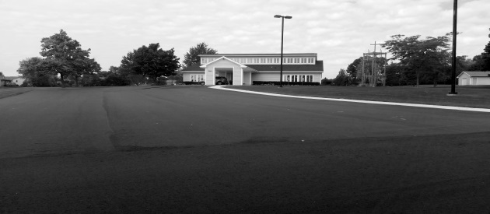

**Church School News**

MC900391546[1] ***The Upper Room*** MC900391546[1]

The Nov/Dec issue of the daily devotional “The Upper Room” is available in the

Literature Rack.

**Items for the Food** Pantry -The month of November donations may be placed in the basket, located in the church office:  **Canned meats**

**Change for Change Jar** - Money used to purchase items for food pantry

**Prayer Shawl/Blankets** – For those in our prayers, items can be found in the office. If you know of someone in need of a shawl/blanket, please select an item to present to them.

**Beverage Tabs for the Ronald McDonald House**

Birthday Bags **– Thank you to all that supported our Birthday Bag mission for another year. Know your efforts brighten others special day. Watch for the 2020 list in December.**

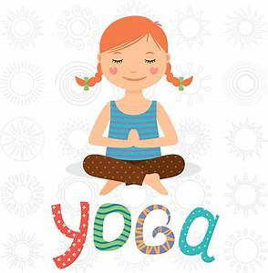

**Slow Flow Yoga**

September 9th Slow Flow Yoga classes will resume at Our Shepherd UCC. The classes are perfect for all levels, even a beginner. The chair yoga class start time will be at 11:00 a.m. and the regular yoga start time will be at 5:30 p.m. Jessica Kohn has consented to be our instructor for another year. There will be two sessions prior to Christmas. The cost for the first 8-week session is $48. Drop in fee will remain at $10 a session.

We are always looking for new friends to join our program.

Questions please contact Renae at 565-2785 or [rwunsch@hgsd.k12.wi.us](mailto:rwunsch@hgsd.k12.wi.us)

Church School News

Church school is offered to children ages 3 to confirmation age. The program runs from 8:30 a.m. to 9:45 a.m. weekly, followed by church services at 10:00 a.m. from September to May.

Studying Deep Blue, the children are reminded they are part of God’s larger family. Stories studied were Peter and John, and the First Called Christians.

The children have been using the Lord’s Prayer as a model to review how they can pray anywhere at any time. Finger 1: Addressing our Father in heaven, Finger 2: Offering praise to God, Finger 3: Laying needs before the Father, Finger 4: Praise and glory, Finger 5: Closing in his name. The children understand praying for others, and praying for needs not wants.

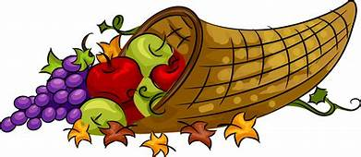November 17 the church school will be sponsoring a Thanksgiving food drive for the local food pantry. Items that might be used for a Thanksgiving meal: canned cranberry, pumpkin, vegetables, boxed potatoes, stuffing or soup are just a few ideas. Bring the items to church on the November 17th and share the bounty of the season.

Christmas Eve is just around the corner and the youth of the church will be leading the evening service. They will be telling the story of Jesus’ birth with a program entitled, “Manger Tales”. Come hear the animals tell about their experience on this very special night. The time for the evening service is still being determined. All youth will be practicing the Sundays prior to the service during church school time, December 1, 8, 15, and dress rehearsal on the 22. Please have your children attend these very important dates so we are prepared for the Christmas Eve service.

**SHOP WITH SCRIP**

Continuing in 2019,

card orders will be due the 3rd Sunday of every month.

**Don’t worry; we will have a stockpile of the cards purchased most often that you can buy any Sunday. It’s best to get that order in on a monthly basis so you can plan for it in your budget.**

Any questions, talk to Shari Ver Straate, Renae Wunsch, Nancy Cherney or Char Gumm.

Thanks for supporting this program.



***The Falls Food Pantry serves the needy of Howards Grove, Kohler, Sheboygan Falls and Waldo. All donations are very much appreciated.***

**God’s Blessings on your Birthday - November**

MC900413580[1]4 Austin Eisentraut 6 Brandon Meyer

8 Hoyt Heinemann 10 Helen Harms

11 Heidi Widder 12 Justin Luebke

13 Carla Hemb 14 Avery Wiegand

15 Jim Vasconi 20 Corey Munger

20 Dan Luebke

**Children’s Room**

Please watch the binder for an opportunity to sign up and cover the children’s room during the morning worship. Your support is greatly appreciated.

Thanks for supporting this program.



**Praiseworthy Notes**

October 30, Wednesday 6:30 Practice

November 3, Sunday 8:45 Practice

10:00 Worship

November 13, Wednesday 6:30 Practice

November 17, Sunday 8:45 Practice

10:00 Worship

Dear Friends in Christ,

There are a lot of myths around the first American Thanksgiving in 1621, but one thing is for sure. The Pilgrims were lucky to be alive, and they knew it.

“Eleven months earlier the Pilgrims had arrived at the tip of Cape Cod, fearful and uninformed,” says Nathaniel Philbrick in his history [*Mayflower*](https://www.amazon.com/exec/obidos/ASIN/0143111973/mhyatt-20). “By all rights, none of the Pilgrims should have emerged from the first winter alive.”

But they did. Thanks to God, their faith, and help from many Native Americans, they did more than survive. They began to flourish. And it’s a virtuous circle.

Most of us know this from personal experience, but for the last several years researchers have come to the conclusion that gratitude is a key component of helping people live happier and longer.

I know this is true in my life. It seems the more I give thanks, the more reasons I have for gratitude.

We all know that materialistic people who expect possessions to make them happy are usually unhappy—no matter how much stuff they get their hands on.

The reason, according to [researchers at Baylor University](http://www.psmag.com/navigation/health-and-behavior/recipe-happy-life-less-materialism-gratitude-76597/), is that by focusing on what we do not have, we are less likely to give thanks for what we do. And gratitude leads directly to feelings of satisfaction and wellbeing.

How? According to [research reported by Robert A. Emmons and Anjali Mishra](https://www.amazon.com/exec/obidos/ASIN/0195373588/mhyatt-20), there are several scientifically supported ways gratitude helps us flourish. Here are four I found especially compelling:

1. **Gratitude reduces our stress.** Thankfulness redirects our attention from our difficulties to the benefits we enjoy. It’s like creating a stockpile of good thoughts for when times are tough. It also helps us reframe our losses and stay connected emotionally to friends and family.
2. **Gratitude inoculates us from negative emotions.** When we focus on what we don’t have or how our decisions could have turned out better, we leave room for resentment, envy, and regret to build. Gratitude can keep these feelings at bay.
3. **Gratitude sustains our relationships.** Let me just ask, Do you like hanging out with people that gripe and complain? Me neither. It’s gratitude that draws people together, builds trust, and strengthens ties. That’s true in the workplace, among friends, in families, and between husbands and wives.
4. **Gratitude improves our health.** Grateful people visit their doctors less often and live longer than others. The research shows that thankfulness helps us sleep better, control our blood pressure, and generally reduce physical complaints.

Given these four ways gratitude can benefit us, I’d say we have some very good reasons to return thanks more than once a year. Cultivating gratitude makes each day worth living and might even give us more days.

Give thanks to God for in doing so we get to see the benefits of gratitude. Come to worship and give thanks. Peace and joy, Pastor Tom

**SUNDAY WORSHIP– 10:00 A.M.**

September - May

**Adult Education opportunity**

We will finish off the series “Be the Church” with the last of my travelogue/discussion sessions on Sunday, November 3 at 8:45. I hope to see you there.



**CLEANING HELP!!!**

There is always something to do no matter if we are at home or at church! I am talking about cleaning!! Ugh! But we need your help! In the binder there is a schedule for volunteers to do a little cleaning.

The list of tasks will be on the bulletin board in the Consistory Room. The dates will be laid out in two week segments and you are welcome to clean any time in those two weeks. Check the binder for your time to spruce up God’s house – which is also home to all of us.

So! Find a friend, do a little cleaning and then head out to eat or do something fun!

All the help you give will be greatly appreciated!!

Thanks,

The Consistory

**Thanks to everyone that has taken a turn cleaning the church. If you haven’t had a chance to help, check the binder for available dates.**

**GIVE GOD OUR BEST**

The cards are out, and now we look to you for help. The consistory is in the process of putting together a budget for 2020. In order to know how to use the resources at hand, they need to know what those resources will be. GIVE GOD OUR BEST is one way you can help. When you get your card, pray about how much you might be willing to give to the work of God through Our Shepherd UCC. After your prayerful consideration, either mail the card back to the church or bring it in by November 10. In this way you will help Our Shepherd UCC plan for the future.

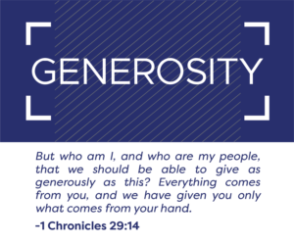

**Confirmation Class**

The confirmation class will meet on November 24 at 8:30.

On December 14, 2019, the Women’s Fellowship will be sponsoring the annual Cookie Walk. Start planning your baking days and **please save your ice cream buckets.**

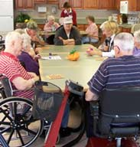**Rocky Knoll Health Care Center** is sharing the opportunity to be a Secret Santa to one of the residents. If you would like to donate small gift items instead, they would be used to make each gift special. Extra items will be used in resident activity programming throughout the year as prizes. **There is a list on the bulletin board of small gift ideas and information on how to become a Secret Santa. Please take one. All Items need to be in by December 1st.**

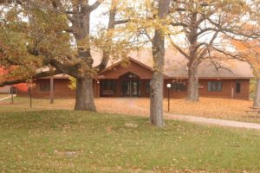

*Pilgrim Center work camp will be held June 7-11, 2020.*

*See Hoyt for details.*

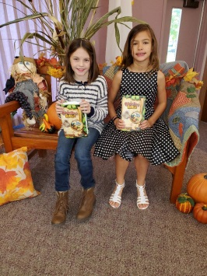*On Sunday October 20th, the 3rd Graders received their Bibles.*

*Pictured are Sohpia and Eleanor. Missing – Colby*

*The church School teachers were also installed.*

*Renae Wunsch – Director, Sarah Breher, Kalena Wesener, Heidi Widder, Nicole Twohig, Tracy Sommer, Darlene Meyers, Kay Sheahan*

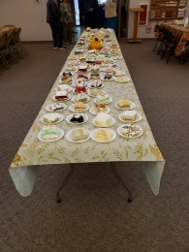*Thank you to everyone that made the Chili Supper a huge success.*

*We made around $1500.00*

*Help decorate the Sanctuary for the Advent and Christmas season on Saturday, November 30th.*

*Watch the bulletin for time and more information.*

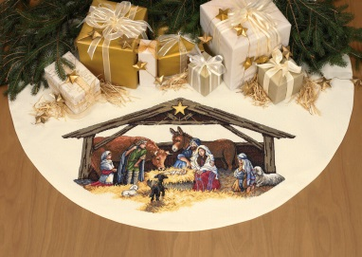

|  |  |  |  |  |  |  |
| --- | --- | --- | --- | --- | --- | --- |
| See the source imageFood Pantry Items  Canned Meat | November 2019 |  |  |  | 1 | 2  Turn your clocks back 1 hour |
| 3  8:30 Church School  8:45 Praiseworthy Practice  10:00 Worship | 4  11:00 Chair Yoga  5:30 Yoga | 5  Dartball  St. Paul @OS  7:30 | 6 | 7 | 8 | 9 |
| 10  8:30 Church School  10:00 Worship  Randy Koppenhaver, Lay pastor | 11  11:00 Chair Yoga  See the source image5:30 Yoga  **Veteran’s Day** | 12  Dartball  OS @ Bummy’s  7:30 | 13 | 14 | 15 | 16 |
| 17  8:30 Church School  8:00 Consistory Meeting  8:45 Praiseworthy Practice  10:00 Worship  **Thanksgiving Food Drive Items Due**  **Scrip Card orders Due**  **Newsletter Articles Due** | 18  11:00 Chair Yoga  5:30 Yoga | 19  Dartball  Plankroad @ OS  7:30 | 20 | 21 | 22 | 23 |
| **24**  8:30 Church School  8:30 Confirmation Class  10:00 Worship | 25  11:00 Chair Yoga  5:30 Yoga | 26  Dartball  Off for Thanksgiving | 27 | 28  Thanksgiving Day  See the source image | 29 | 30 Help  Decorate church for the Advent and Christmas Season  Time to be determined |