**Consistory Pastoral Relations Officers**

Ann VanWyk –President Hoyt Heinemann-Chair

Neal Henschel - Secretary Nicole Twohig-Sec Mandi Grube-

Nancy Cherney Nancy Henschel Treasurer

Karl Grube Kyle Stowers

Kyle Stowers Carla Hemb-

Church & Financial Sec

***Prayer Concerns…***

*Please keep those who are shut-in or ill in your prayers.*

*Stella Miller – 326 Isabelle Court*

*Sheboygan Falls, WI 53085*

*Cell: 920-889-8366*

*Kathleen Grube -Terrace Estates*

*1231 Eisner Ave*

*Sheboygan, WI 53083*

*Darwin & Jean Meyer 2005 Appletree Road Room 4*

*Howards Grove, WI 53083*

*Cleora Marx 110 S. Pershing Avenue*

*Howards Grove, WI 53083*

*Doris Hanke 715 S. Lincoln Apt 4*

*Howards Grove, WI 53083*

**The Shepherd’s Word**

**Our Shepherd UCC**

**710 Ethan Allen Drive**

**Howards Grove, WI 53083**

**The Shepherd’s Word *October* 2020**

**Our Shepherd UCC Pastor Nathan Athorp**

**920-565-3376 ourshepherducc.com**

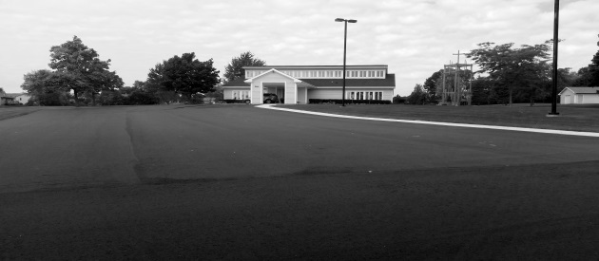

**Some Church Activities have been**

**cancelled or postponed.**

**Outdoor services will continue as the weather permits**

**Please check the**

**Our Shepherd Facebook page or**

**Website (ourshepherducc.com) to get updates as to when and how things**

**will be changing.**

**Watch the Facebook page for special music and weekly church services**

**You can also get messages from**

**Pastor Nathan Athorp through**

**Facebook, phone call or email**

Contact information:

**Cell: 920-946-3585 Church 920-565-3376**

**e-mail: nathorp70@gmail.com**

**Chili Supper**

We are trying something new with our Chili Supper this year: **Drive Thru Only**

Instead of tortes, we will offer Apple Crisp. The same recipe we used for our Chicken Dinner.

Please watch for sign-up sheets to help with the Chili Supper on October 21st, 4pm-7pm.

**Church School News**

Items for the Food Pantry The month of Octoberdonations may be placed in the basket, located in the office area: **Cereal**

**Change for Change Jar** - Money used to purchase items for food pantry

**Prayer Shawl/Blankets** – For those in our prayers, items can be found in the office area. If you know of someone in need of a shawl/blanket, please select an item to present to them.

**Beverage Tabs** for the Ronald McDonald House

**Birthday Bags** -Sign up to supply items needed for a birthday bag, to be delivered to the food pantry. Choose a month, bring the items to church, the bag is supplied by the church school. (In a bag: box of cake mix, small bottle of oil, can of frosting, candles – eggs supplied by food pantry)

**Thank you to those that continue to supply items for birthday bags.**

**Church School News**

Church school is offered to children age 3 to confirmation. The program runs from 8:30 to 9:45 weekly, followed by church services at 10:00

**B**: Be with God **L**: Love God & neighbor **U**: Understand yourself as a child of God **E**: Explore the Bible

**From the Pastor**

Time sure does fly when you are having fun! That phrase seems to really ring true for me lately, I am having a lot of fun here at Our Shepherd and somehow we are finding ourselves looking at October already. Where has the last two months gone? With the arrival of cooler nights and the slightest hints of color in the trees we know that fall is coming and with that arrival we would expect certain events to be happening. The pandemic is certainly throwing us a curve ball and we are dealing with multiple unknowns, but I want to take some time to update you on a couple of traditional events here at Our Shepherd.

We would normally be started Sunday School sometime in September. After multiple conversations with the Sunday School team we have decided that we simply cannot make this happen in a traditional manner right now. We typically bring children together from multiple school districts and from multiple age groups. This gathering would be contrary to what our schools are trying to do, keeping children with their grades and not having a significant amount of co-mingling. I am working closely with the team to develop an alternative offering for our children.

This year we have one student eligible for confirmation and we are moving ahead with that program, although we are doing things a little differently. We are partnering with Bethel UCC near Ada for confirmation. They have three students and if we work in partnership with them our discussions and time together will certainly be richer than if we would be working on this alone.

The changing seasons are reminding us that our ability to have outdoor worship is coming to a close. I believe we have a plan that will allow us to safely worship inside. Keep your eyes open for a separate announcement concerning this. Moving inside means we will need to be taking additional safety precautions and it is going to require a dedicated cleaning routine. I am looking for a team to lead this process, if we work together I am hopeful the task will be manageable. If you are willing to be part of this effort, please let me know.

Psalm 89:28 reminds of us God’s steadfast presence during these times. “Forever I will keep my steadfast love for him, and my covenant with him will stand firm.” We are not enduring these times alone.

-Peace,

Pastor Nathan

**SHOP WITH SCRIP**

Continuing in 2020,

card orders will be due the 3rd Sunday of every month.

**Don’t worry; we will have a stockpile of the cards purchased most often that you can buy any Sunday. It’s best to get that order in on a monthly basis so you can plan for it in your budget.**

MC900391546[1] ***The Upper Room*** MC900391546[1]

The Sept/Oct issue of the daily devotional “The Upper Room” is available in the Literature Rack.



**Until further notice Yoga is postponed** honoring no group larger than 10 to gather in one place. An email will be sent to participants when we will resume. If you or someone you know would like this notification please contact Renae at the number/email listed below.

We are always looking for new friends to join our program.

Questions please contact Renae at 565-2785 or [rwunsch@hgsd.k12.wi.us](mailto:rwunsch@hgsd.k12.wi.us)

Any questions, talk to Shari Ver Straate,

Renae Wunsch, Nancy

Cherney or Char Gumm.

Thanks for supporting this program.

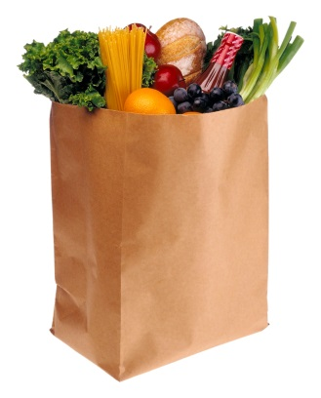

***The Falls Food Pantry serves the needy of Howards Grove, Kohler, Sheboygan Falls and Waldo. All donations are very much appreciated.***

**God’s Blessings on your Birthday - October**

3 Daryl Gabsch 4 Michael Wieck

5 Kathleen Grube 16 Neal Henschel

16 Korynn Wesener 19 Kyle Stowers

20 Phil Walkenhorst 23 Ed Aschenbach

24 Jim Milbrath 24 Anora Barber

27 Mandi Grube 27 Mark Vollbrecht

28 Kay Sheahan 30 Megan Schueler

**CLEANING HELP!!!**

There is always something to do no matter if we are at home or at church! I am talking about cleaning!! Ugh! But we need your help! In the binder there is a schedule for volunteers to do a little cleaning.

The list of tasks will be on the bulletin board in the Consistory Room. Check the binder for your time to spruce up God’s house – which is also home to all of us.

So! Find a friend, do a little cleaning and then head out to eat or do something fun!

All the help you give will be greatly appreciated!!

**Thanks to everyone that has taken a turn cleaning the church. If you haven’t had a chance to help, check the binder for available dates.**

Thanks, The Consistory

**Dartball**

We are always looking for more dartball players, if interested Call Hoyt Heineman at 565-3211. We will not be starting the season until it’s okay to meet in groups. Possibly in the new year.

**Praiseworthy Notes**

**FAITH IN THE FALL 2020 UPDATE**

Dear Friends,

Some of you have asked about whether or not we will be having “Faith in the Fall” in 2020. At this time, we are not planning on having the music festival. We may do some type of mini “Faith in the Fall,” later in the season when we are able to praise God together again in song. Until then, God bless.  ~Kay

Sunday Worship 10:00 am

September-May



Dear Friends in Christ,

As we stay home, please remember our friends and family in your thoughts and prayers.

Seeing as we will not have face to face worship, Our Shepherd has two options for providing your offering:

1. Sending a check via postal mail to the church
2. Using your bank’s online bill pay to send a check to church

Mail all checks/bill pay out to:

Our Shepherd UCC

710 Ethan Allen Drive

Howards Grove, WI 53083

Yours in Christ,

Mandy Grube, Treasurer

**Grateful Weekly Offerings**

Supporting the church can be done by mailing your offering directly to the church or on-line bill pay (Please enter your envelope number in the account number field when using on-line banking).

Our Shepherd UCC

710 Ethan Allen Drive

Howards Grove, WI 53083

**Opportunity**

Have you considered serving Our Shepherd as a consistory member? We have three openings coming up at the end of the year. Yes, this time certainly has its challenges, but this is also a time when we have an opportunity to position our church for some amazing future ministry. If you are interested in exploring this opportunity please talk to an existing consistory member or Pastor Nathan.

**Scrip Card Sales**

We will continue to sell Scrip cards at church.

If you want to purchase any cards please contact Shari Ver Straate at

565-3737 or [verstraates@yahoo.com](mailto:verstraates@yahoo.com)

for information.

Thank you for your support

**Brats, Brats and more Brats**

Two Brat Frys on October 3rd.

8am-3pm

Come support Our Shepherd at Miesfeld’s or Piggly Wiggly in Howards Grove

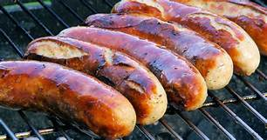



Thanks to the garden angel who cleaned the weeds from under the cross structure and flowerbeds.

Thanks also goes out to all who mow the lawn and trim the edges. You make Our Shepherd look like a welcoming place to be!

**Changes to the Giving Tree**

Our Shepherd is once again participating in the Salvation Army’s **Adopt-a-Family** Christmas Program. Due to the COVID-19 pandemic, the Salvation Army is doing things a little differently this year. They are starting a new program called **Cards for Kids** and we are being invited to participate. We are being asked to purchase gift cards instead of the gifts that were purchased in past years. The suggested sources of these cards are**; Bath and Body Works, CVS Pharmacy, Fleet Farm, Kohls, Meijer Store, Starbucks, Target, Walgreens, and Walmart**.

All of these vendors are available through our Scrip program. The total amount of gift cards purchased is up to your discretion, however we ask that you purchase cards in smaller increments, with $25 being an ideal amount.  You will not receive specific family information as in years past. Instead, all the donated gift cards will be pooled and then divided amongst the families in need. How much is distributed per child will be determined by the total amount received for the **Cards for Kids** program.

In order to make this all happen **the cards need to be purchased by November 15th, please see Shari** if you would like to purchase cards.

We will have a special order form to make the process easier.

**Crop Walk**

There are many countries around the world who have a better life because of our support with the Crop Walk. For example in Viet Nam we help teams of workers learn to build low-cost water purification systems. By using these systems families and schools have access to clear water. There are many countries around the world who have a better life because of our support.

The Crop Walk helps support over 1600 local organizations around the United States including organizations in our community. **A percentage of money collected remains in our community.** The walk provides healthy meals while educating the public not only on the problems of, but more importantly the solution to the issues of domestic hunger according to Ron Pringle, a food bank director.

The Crop Walk is scheduled for Sunday, October 11 at 12:30 in Howards Grove. It will start and end at Memorial Park Pavilion. One person from each church will register people so that we don’t have a line of people. You can do a 2 or 4 mile walk. Envelopes for pledging are available in the church office. If you are not able to walk consider pledging for some who are walking. Last year we raised $6,140 between our 6 rural churches. Our Shepherd raised $95. We had one lone walker. Can we increase that amount this year? You can also raise funds online by registering at **crophungerwalk.org** and invite others to support ending hunger.

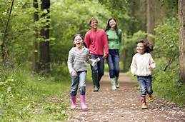



Chili Supper

Wednesday October 21, 2020

4:00-7:00PM

at

Our Shepherd UCC Church

710 Ethan Allen Drive

Howards Grove

**Drive Thru ONLY!**

Dinners include: Chili, fresh bread, fresh cheese,

crackers and homemade apple crisp

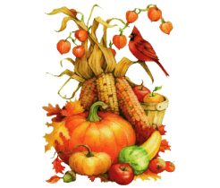$8.00

|  |  |  |  |  |  |  |
| --- | --- | --- | --- | --- | --- | --- |
| Food Pantry Items |  |  |  | 1 | 2 | 3  Brat Fry at Miesfeld  &  HG Piggly Wiggly |
| 4  10:00 Worship - on Facebook and outside (weather permitting) | 5  Labor Day | 6 | 7 | 8 | 9 | 10 |
| 11  10:00 Worship – In person and on Facebook | 12 | 13 | 14 | 15 | 16 | 17 |
| 18  10:00 Worship – In person and on Facebook  **Scrip Orders Due**  **Newsletter Articles Due** | 19 | 20 | 21  Chili Supper  4-7  Drive Thru Only | 22 | 23 | 24 |
| 25  10:00 Worship - – In person and on Facebook | 26 | 27 | 28 | 29 | 30 | 31  October  2020 |