**Consistory Pastoral Relations Officers**

Ann VanWyk –President Hoyt Heinemann-Chair

Neal Henschel - Secretary Nicole Twohig-Sec Mandi Grube-

Nancy Cherney Nancy Henschel Treasurer

Jamie Eisentraut Kyle Stowers

Kyle Stowers Carla Hemb-

Karl Grube Church & Financial Sec

***Prayer Concerns…***

*Please keep those who are shut-in or ill in your prayers.*

*Stella Miller – 326 Isabelle Court*

*Sheboygan Falls, WI 53085*

*Cell: 920-889-8366*

*Kathleen Grube -Terrace Estates*

*1231 Eisner Ave*

*Sheboygan, WI 53083*

*Darwin & Jean Meyer 2005 Appletree Road Room 4*

*Howards Grove, WI 53083*

*Cleora Marx 110 S. Pershing Avenue*

*Howards Grove, WI 53083*

*Doris Hanke 715 S. Lincoln Apt 4*

*Howards Grove, WI 53083*

Ken Gumm *N6222 Woodland Road*

*Sheboygan, WI 53083*

**The Shepherd’s Word**

**Our Shepherd UCC**

**710 Ethan Allen Drive**

**Howards Grove, WI 53083**

**The Shepherd’s WordAugust 2020**

**Our Shepherd UCC Pastor Nathan Athorp**

**920-565-3376 ourshepherducc.com**

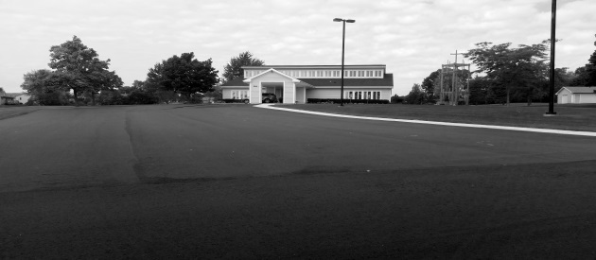

**All Church Activities have been**

**cancelled or postponed.**

**The Newsletter has been printed as if events will be happening as usual.**

**Please check the**

**Our Shepherd Facebook page or**

**Website (ourshepherducc.com) to get updates as to when and how things**

**will be changing.**

**Watch the Facebook page for special music and weekly church services**

**You can also get messages from**

**Pastor Nathan Athorp through**

**Facebook, phone call or email**

Contact information:

**Cell: 920-946-3585 Church 920-565-3376**

**e-mail: nathorp70@gmail.com**

**Consistory Update**

Hello to Our Shepherd UCC Congregation as we are entering the middle of summer and still have not reopened up the church because of the Covid-19 virus we have had a lot of things happening with the church. The search committee has recommended the hiring of Rev. Nathan Athorp and you the congregation voted 100% to hire him on as our next Pastor of Our Shepherd UCC. Rev. Nathan will start August 1st this will bring new delight to the congregation to have a fulltime Pastor with new energy and productive visions for the future of the church.

With having a new fulltime pastor comes with responsibilities of the congregation to be there for Rev. Nathan Athorp to support his leadership with our time, talents, and our financial giving to make his start here at Our Shepherd UCC a positive beginning.

The hardest part of hiring of Rev. Nathan Athorp is having to say goodbye to Pastor Dianne. She encountered the situation of Covid-19 and had no formal training on how to go about handling this pandemic, yet took charge and made sure everyone’s needs were met each week. I’m sure God sent her to us knowing she would be the right fit for our congregation during this challenging time in the world. All you who have been lucky enough to know Pastor Dianne on a personal level have truly been blessed. So, thank you Pastor Dianne for all you have done during this difficult time.

**Sacraments – Communion Sunday: August 2nd.**

**Committee Reports:**

**Building and Grounds:** Meeting was for water drainage issues in front of church yard with Village they will get their engineer to look at the problem.

**Christian Education:** No VBS, might see how things go and do a one-day event.

**Music:** Praiseworthy will not be singing for a while but we will have Stephanie playing piano. No Faith in the Fall this year.

**Finance & Stewardship Committee:**

Need withdrawal from building fund for window which we paid with general fund money will do this before the end of the year.

**Women’s Fellowship:** Stain Glass windows are on hold might do windows by front doors with etching. Will be getting new blinds for window old one too wide.

**New Business:** Hired Pastor Nathan Athorp; 100% votes were YES. Need to get contracts signed and pay his mileage and background check.

Will have to follow guidelines to reopen church back up again.

Church needs a good cleaning.

Extension with Pastor Dianne through July 31, 2020

No Fair Concession Stand

Chili Supper? Sincerely, the Consistory

**Church School News**

Items for the Food Pantry The month of August donations may be placed in the basket, located in the office area:

School Supplies

**Change for Change Jar** - Money used to purchase items for food pantry

**Prayer Shawl/Blankets** – For those in our prayers, items can be found in the office area. If you know of someone in need of a shawl/blanket, please select an item to present to them.

**Beverage Tabs** for the Ronald McDonald House

**Birthday Bags** -Sign up to supply items needed for a birthday bag, to be delivered to the food pantry. Choose a month, bring the items to church, the bag is supplied by the church school. (In a bag: box of cake mix, small bottle of oil, can of frosting, candles – eggs supplied by food pantry)

**Thank you to the Mair and Wunsch families for supplying birthday bags during our time of virtual church services.**



Church school is offered to children age 3 to confirmation. The program runs from 8:30 to 9:45 weekly, followed by church services at 10:00

B: Be with God L: Love God & neighbor U: Understand yourself as a child of God E: Explore the Bible

Greetings to Everyone!

August is upon us and we have certainly found ourselves in the midst of some interesting times. Traditionally we would be planning some sort of a meet and greet to celebrate the beginning of our new ministry together. We would gather together, probably shake lots of hands, maybe eat some cake, and share some stories. Unfortunately, under our current Covid-19 circumstances it seems like a poor idea for us to be gathering in large numbers to do any sort of a celebration. The last thing any of us want is an uptick in Covid cases to mark the beginning of our time together. We really do not know when we will be able to gather in a manner that resembles what we used to do, but I remain optimistic that we will be able to gather in new ways. I am in close contact with both our Wisconsin Conference and with the Wisconsin Council of Churches and we will be exploring what we believe to be safe and responsible ways of getting to know each other. I am hopeful that we will be able to host some outdoor worship events as the summer progresses and I am looking forward to taking advantage of our great weather as a means to meet safely with plenty of fresh air flowing.

Our faith history contains multiple stories of populations who have faced unknown futures, I am thinking specifically of the Israelites as they left Egypt following Moses into the Wilderness, or the Disciples huddled in a room after Jesus has been crucified. In these cases there were many unknowns concerning the future, however throughout everything the presence of God remained constant. God accompanied the people regardless of what the circumstances threw at them. In the same way, I am confident God is with us today, it is up to us to remain open to that presence and receptive to how we are being called to live as the Church today. I truly believe it is important for us to maintain a position of flexible optimism as we move forward during this time and I encourage you to ‘stay tuned’ for further announcements as to how we will be worshipping and serving.

-Blessings,

Rev. Nathan Athorp

**SHOP WITH SCRIP**

Continuing in 2020,

card orders will be due the 3rd Sunday of every month.

MC900391546[1] ***The Upper Room*** MC900391546[1]

The July/Aug issue of the daily devotional “The Upper Room” is available in the Literature Rack.

**Don’t worry; we will have a stockpile of the cards purchased most often that you can buy any Sunday. It’s best to get that order in on a monthly basis so you can plan for it in your budget.**

Any questions, talk to Shari Ver Straate,

Renae Wunsch, Nancy

Cherney or Char Gumm.

Thanks for supporting this program.



***The Falls Food Pantry serves the needy of Howards Grove, Kohler, Sheboygan Falls and Waldo. All donations are very much appreciated.***

**God’s Blessings on your Birthday - August**

11 Victoria Eisentraut 13 Ava Ver Straate



**Until further notice Yoga is postponed** honoring no group larger than 10 to gather in one place. An email will be sent to participants when we will resume. If you or someone you know would like this notification please contact Renae at the number/email listed below.

We are always looking for new friends to join our program.

Questions please contact Renae at 565-2785 or [rwunsch@hgsd.k12.wi.us](mailto:rwunsch@hgsd.k12.wi.us)

16 Richard Wixon 18 Todd Stoffregen

21 Amanda Vasconi 26 Nancy Henschel

**CLEANING HELP!!!**

There is always something to do no matter if we are at home or at church! I am talking about cleaning!! Ugh! But we need your help! In the binder there is a schedule for volunteers to do a little cleaning.

The list of tasks will be on the bulletin board in the Consistory Room. The dates will be laid out in two week segments and you are welcome to clean any time in those two weeks. Check the binder for your time to spruce up God’s house – which is also home to all of us.

So! Find a friend, do a little cleaning and then head out to eat or do something fun!

All the help you give will be greatly appreciated!!

**Thanks to everyone that has taken a turn cleaning the church. If you haven’t had a chance to help, check the binder for available dates.**

Thanks, The Consistory

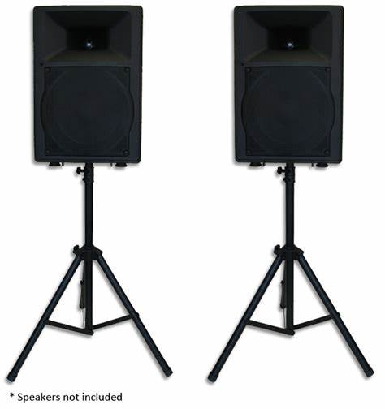

**SPECIAL THANKS**

**Thank you to Praiseworthy for purchasing speakers to make outdoor worship possible. Additionally, a very special thank you to Jeff Wunsch for researching, ordering, setting up, and running the speaker system. Way to go Jeff!**

**Praiseworthy Notes**

**FAITH IN THE FALL 2020 UPDATE**

Dear Friends,

Some of you have asked about whether or not we will be having “Faith in the Fall” in 2020. At this time, we are not planning on having the music festival. We may do some type of mini “Faith in the Fall,” later in the season when we are able to praise God together again in song. Until then, God bless.  ~Kay



Sunday Worship 9:00 am

June- August

Dear Friends in Christ,

As we stay home these next few weeks, please remember our friends and family in your thoughts and prayers.

Seeing as we will not have face to face worship, Our Shepherd has two options for providing your offering:

1. Sending a check via postal mail to the church
2. Using your bank’s online bill pay to send a check to church

Mail all checks/bill pay out to:

Our Shepherd UCC

710 Ethan Allen Drive

Howards Grove, WI 53083

Yours in Christ,

Mandy Grube, Treasurer

**Grateful Weekly Offerings**

Supporting the church can be done by mailing your offering directly to the church or on-line bill pay (Please enter your envelope number in the account number field when using on-line banking).

Our Shepherd UCC

710 Ethan Allen Drive

Howards Grove, WI 53083

**VBS**

**Knights of North Castle**

**2021**

Postponed until 2021

**Scrip Card Sales**

We will continue to sell Scrip cards at church.

If you want to purchase any cards please contact Shari Ver Straate at

565-3737 or [verstraates@yahoo.com](mailto:verstraates@yahoo.com)

for information.

Thank you to the yoga program for purchasing a new laptop to be used with the projector and sound system. A stand was also purchased to hold equipment for virtual services.



***May light and joy fill your summer days!***

Dear Ones All,

Thank you so much for making my time as your pastor such a joyful and meaningful experience.

I have especially fond memories of throwing extravagant seeds of God’s love at the kids, and the time the congregation was the “storm” while the kids were riding with Jesus in the boat!

I am deeply thankful for the awesome worship team of Kay, Jeff, Stephanie, and Carla, for Renee’s thoughtful ministry with the children, and for the supportive leadership of Shari and Ann.  And thank you Carol Mae for all of the delicious Wednesday treats!

I have been blessed by this congregation’s kindness, and I am grateful for your patience when we suddenly had to go to “Plan B” during the pandemic.

I praise God for you all!



Much love and many blessings,

Pastor Dianne

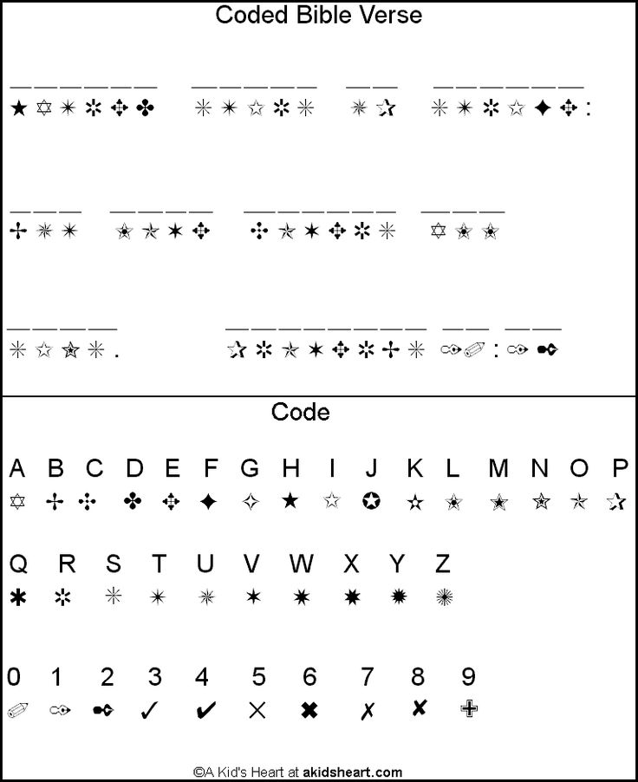

*I am a child of God*

*John 1:12*

|  |  |  |  |  |  |  |
| --- | --- | --- | --- | --- | --- | --- |
| Food Pantry Items  School Supplies |  |  |  |  |  | 1 |
| 2  9:00 Worship - Pastor Nathan Athorp | 3 | 4 | 5 | 6 | 7 | 8 |
| 9  9:00 Worship | 10 | 11 | 12 | 13 | 14 | 15 |
| 16  9:00 Worship  **Scrip Orders Due** | 17 | 18 | 19 | 20 | 21 | 22 |
| 23  9:00 Worship  **Newsletter Articles Due**  30  9:00 Worship | 24  31 | 25 | 26 | 27 | 28  August  2020 | 29 |